**Admission module:**

**Menu 1: initiate admissions.**

This form is all about initiating the admissions for the current academic year. Which will show in which classes, admissions are open.

Dashboard for initiate admissions menu :

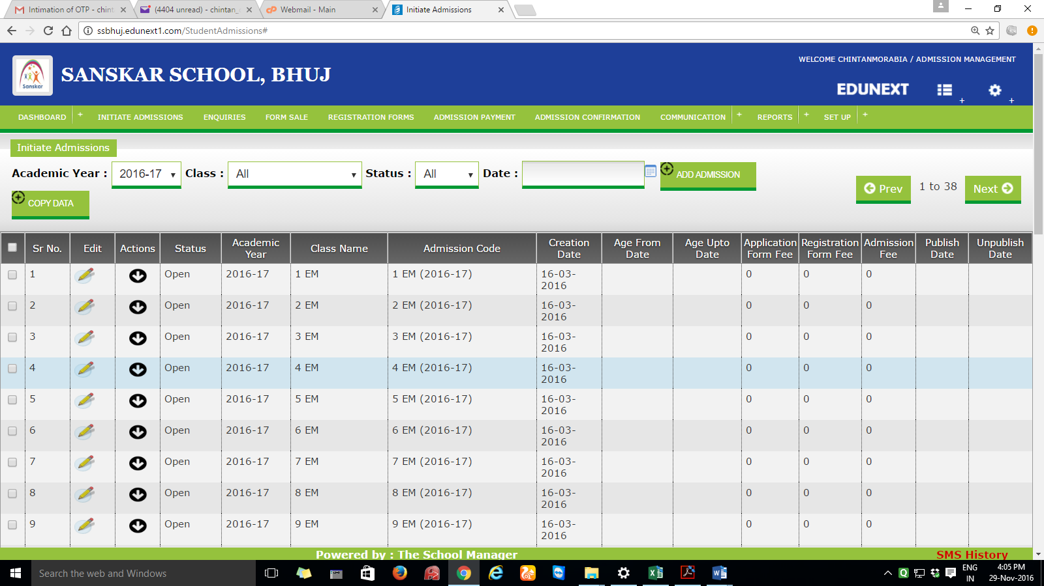

Add admission button: this button will open a new admission for a particular class / section

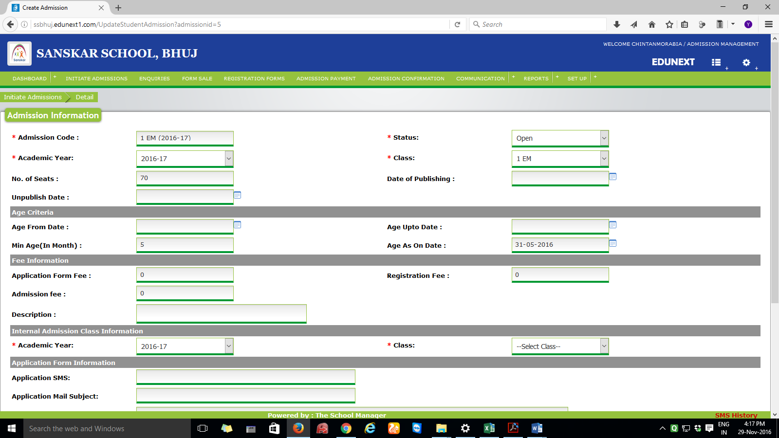

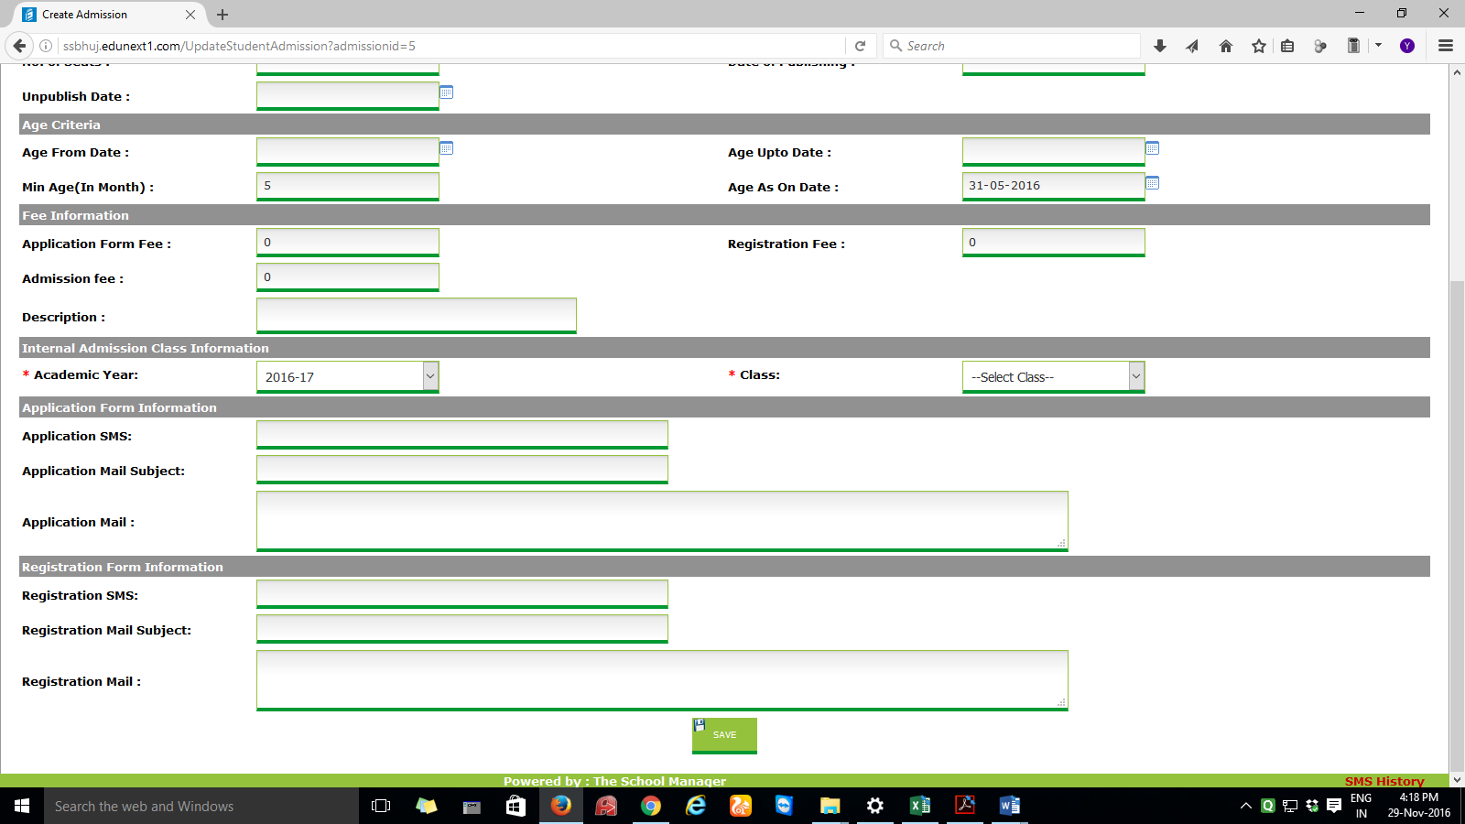

Required fields and its information:

Admission Code: string. This explains the code of the admission which is open. i.e. FYBCA SEM 1 ( 16-17 )

Status: combo. Open / close.

Total No. of seats**: Numeric.

General Quota Seats: numeric

SC Quota seats: numeric

ST Quota seats: numeric

SEBC Quota seats: numeric

Physically Handicapped Quota seats: numeric

Other Board Quota Seats: numeric

Date of publishing: date, starting date from which admissions open

Unpublish Date: date, last date to which admission can be given

** Total seats should be equal to addition of seats entered in different categories

Age criteria: NOT REQUIRED

Fee information:

Inquiry form fee: number

Admission form fee: number

Admission fee: number

Internal Admission class information: this information will tell to which section (FYBBA SEM1 ETC) admission should be transferred once admission is confirmed.

Academic Year: combo to which year year admission should be given

Class: to which section/class admission should be given

SMS: This option will send the SMS to the student’s number

Inquiry SMS: content of the message when someone does the inquiry

Admission application SMS: content of the message when someone applies for the admission

Admission confirmation SMS:content of the message when admission has been confirmed

**MENU 2 : ENQUIRIES: DASHBOARD**

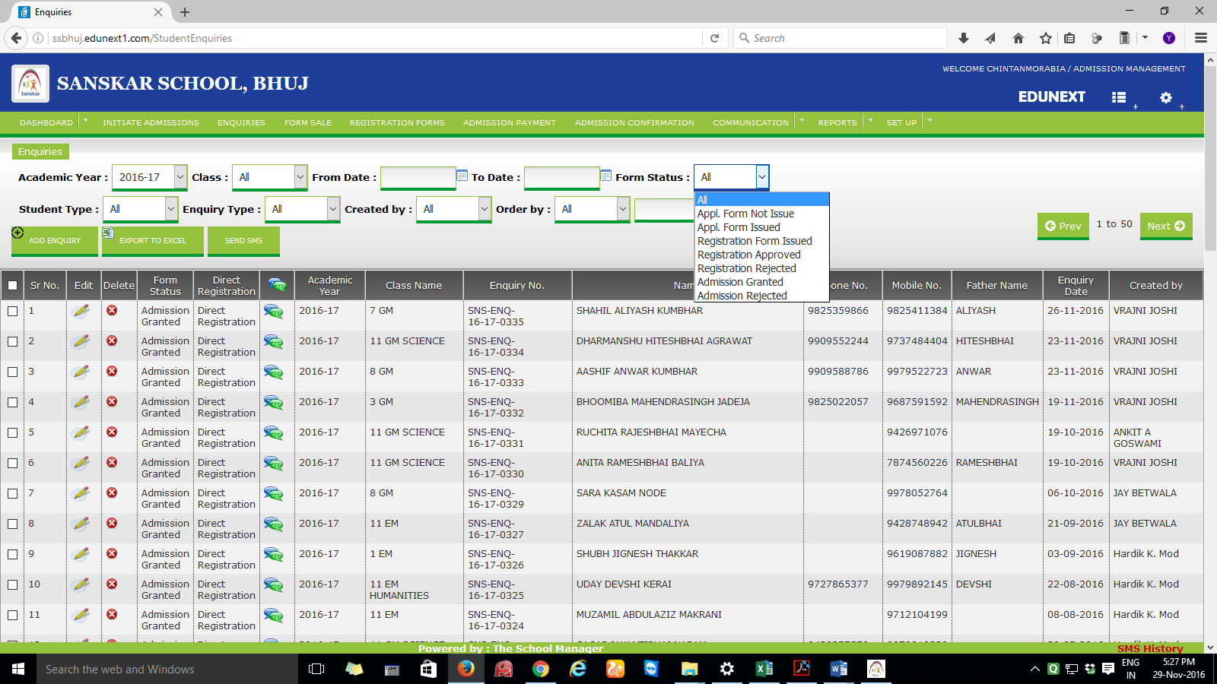

ABOVE MENU FIELD REQUIRED ARE :

Academic year, class, from date, to date, form status : application form not issued, application form issued, admission granted, admission not granted

ADD ENQUIRY MENU :

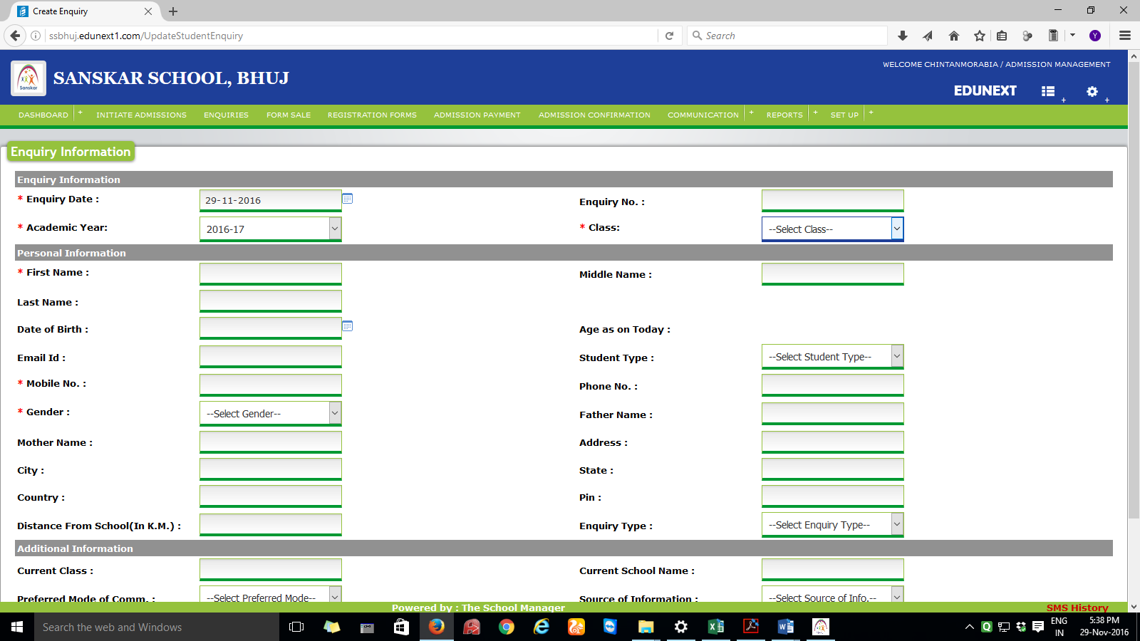

Enquiry information: as it is. Enquiry no to be auto generated.

Personal information: to be added: district, category-combo (open, sc, st, sebc, other board), physically handicapped: yes / no checkbox, profession (after father name), parents mobile number,

To be removed: enquiry type, distance from school

Course information:

Name of Last/ Current school/college :

Address :

Percentage/Grade obtained :

Program of Interest: combo BBA BCA

Semester in which seeking admission: Semester-combo(1 to 6)

Other information:

Preferred mode of communication : phone, sms, email

Source of information: Friends,Faculties,News-papers,Hoardings, Website,Other:specify.

Remarks:

**MENU 3 : Registration / application forms**.

Students who have filled the enquiry forms, can go for next stage that is filling the registration / application form, there will be an option here students who have not filled any enquiry form, can directly go for registration / application form filling also.

home page of this menu :

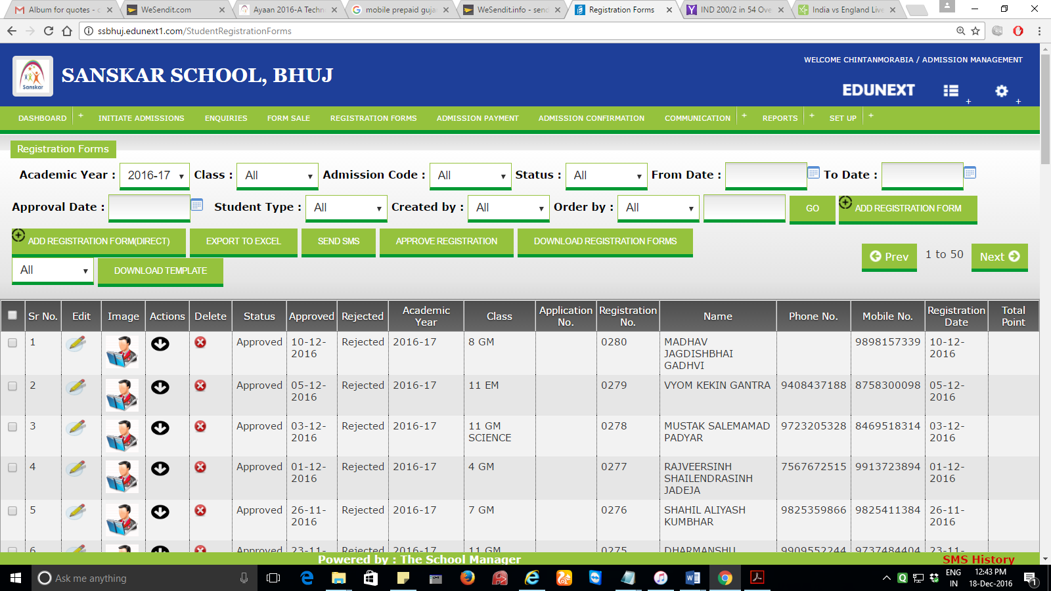

Add registration form :

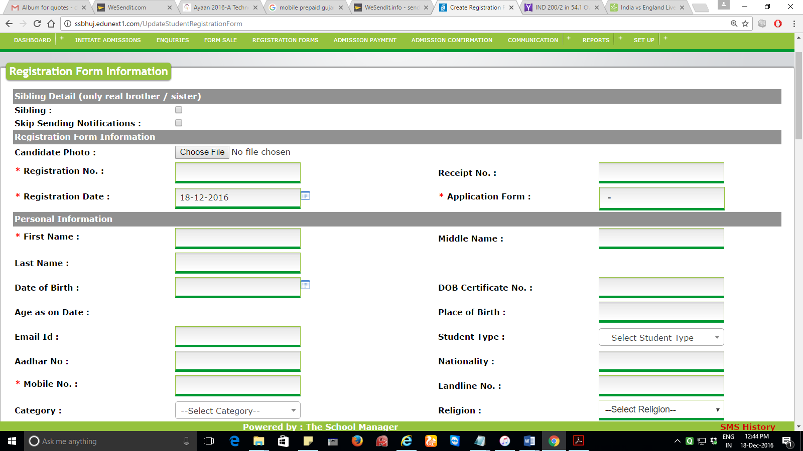

Sibling detail – not needed.

**Registration form information –**

Registration number : system generated,

enquiry form no : to be entered or selected, once number is entered, information which is there in enquiry form, will be auto populated

registration date : date ( by default, current date )

**personal information :**

first name*, middle name*,last name*

mothers name*, gender*,

date of birth*, birth place, marital status,category*, physically handicapped*: yes / no checkbox,

age as on date : auto generated

address :

email id:

mobile number, phone number, parents mobile number,

mother tongue, blood group, country of citizenship,

address*,state*,district,tehsil,city*,pincode*

occupation of guardian : annual income of guardian,

**academic information :**

NAME OF EXAM : as for e.g. 10th, 12th ( multiple entries should be added )

Name of board, university and state of university :

Name of school / college :

Month and year of passing :

Exam seat number :

Certificate number :  
marks obtained :

Out of :

cgpa :

Add registration form ( direct ) : enquiry number will not be there. So all the data have to be inputted.

**MENU 4 GENERATE MERIT LIST:**

Students who have filled up the registration form will be eligible for merit list.

Course : B.B.A./B.C.A.

Merit list number: auto generated, more than one merit list can be generated

Date :

Pls. find the excel copies with this mail to see the report in the way the merit list is getting generated.

**GENERATE**

**MENU 5: ADMISSION CONFIRMATION**

**This menu is for confirming the students admission**

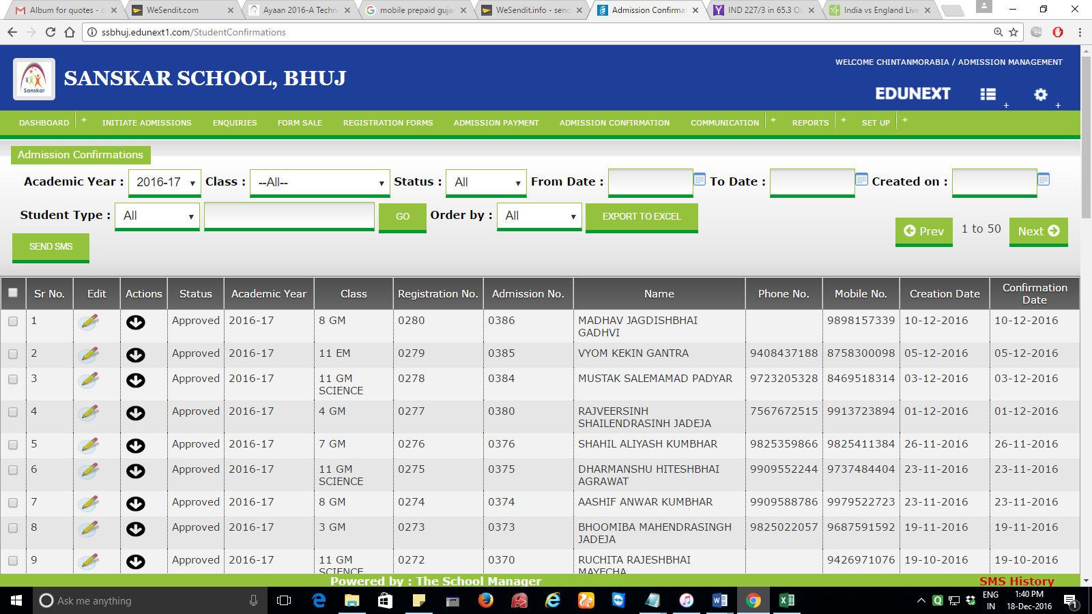

**Heading options :**

**Academic year, class, merit list number**

**Table heading options :**

**Sr.no, edit,actions,status,academic year, class, registration no, merit list no, admission number,name,student mob.,parent mob,registration date,confirmation date.**

**Edit button :**

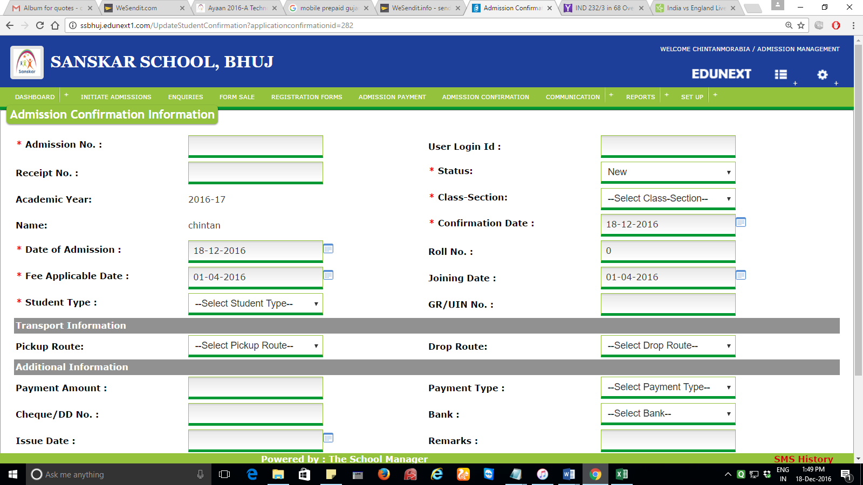

Admission no(auto),status(new,approved,rejected),academic year,class-section(for multiple classes),date of admission, fee applicable date, joining date, quota – apart from general quota, certificate no. is mandatory for approving the admission.

Reports :

1. Inquiry report. (detail, with export facility)
2. Inquiries with & without Application form. (summary)
3. Admission Application form report. (detail report)
4. Merit List Reports
5. Admission Application Form filed, but Admission not approved report. (fees not paid)
6. Total admission Report category wise.
7. Report of students with incomplete document. (detail).??????????
8. Report of management quota if required

Dashboard of admissions.

